In 1996, Siemens presented its new automation concept "Totally Integrated Automation (TIA)" at a press conference in Rotterdam. This concept was the response to a host of questions that had occupied the automation world for years: industrial networking, the shifts from hardware to software, and the functional overlap of previous automation system. PLC资料网

The goal of Totally Integrated Automation was to overcome existing system limits:
•Between the worlds of the computer and the programmable controller
•Between human machine interfacing and control
•And, most impressively, between factory automation and process automation.
This was achieved by one central feature, the three-fold integration of all components of an automation solution:
•In configuring and programming
•In data management
•In communication
PLC资料网

With Totally Integrated Automation, both horizontal and vertical integration is ensured: horizontally from incoming goods, through the entire production chain, right on to outgoing goods, and vertically through all levels of the automation pyramid.
PLC资料网

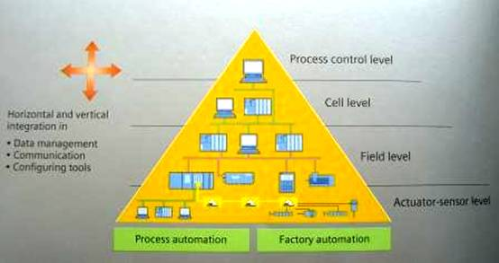PLC

With TIA, Siemens was the first company on the market to consistently implement the trend from the device to the integrated automation solution (and to continuously perfect it in subsequent years).
<译文, By Gongkong〉
说说全集成自动化
1996年，在鹿特丹的一次新闻发布会上，西门子首次提出了全集成自动化的概念。针对工业网络化，硬件到软件的过渡以及原有自动化系统的功能缺陷等诸多困扰自动化届多年的问题， 西门子的这一全集成自动化概念是最好的答案。
全集成自动化是为了克服存在于目前系统中的局限性：
•计算机与编程控制器之间的局限
•人机界面接口设计与控制之间的局限
•工厂自动化与过程自动化之间的局限（尤其显著）
全集成自动化解决方案的核心是实现了三方位的集成：
•集成的配置和编程
PLC资料网
•集成的数据管理
•集成的通信
全集成自动化确保了横向一体化及纵向一体化。横向来看，经过整条生产链，实现了从进货到出货一体化。纵向来看，实现了自动化过程中各个级别的集成。 PLC资料网
============================= PLC
作者 斐德思:2006年10月至今 西门子（中国）有限公司自动化与驱动集团自动化系统部总经理
PLC
这是我第二次转斐德思先生的文章,希望对大家理解TIA全集成自动化有所帮助.
PLC资料网

